Overview of Microsoft System Center Configuration
Manager (SCCM)

Microsoft System Center Configuration Manager (SCCM), now officially known as Microsoft Configuration Manager (and part of the broader Microsoft Intune product family), is a powerful tool for IT administrators to manage large groups of computers and other devices.
Think of it as the central control hub for your entire network. Instead of going to each computer to install software, apply updates, or check for problems, you can do it all from one place.
1. Core Concept
The main purpose of Configuration Manager is to automate and simplify device management. It uses a client-server architecture:
- The Server (Site Server): This is the central hub where you, as the administrator, configure policies, create deployments, and monitor your entire environment.
- The Client: A small piece of software that is installed on every device you want to manage. It talks to the server to get instructions, report its status, and download content.
This model allows you to manage thousands of devices efficiently from a single console.
2. Key Features and Functions
Configuration Manager is a comprehensive suite with many capabilities. The most important ones are:
- Application Management: You can create "packages" of applications and deploy them to users or devices across your network. This includes automating installations and even allowing users to install software on their own through the "Software Center" portal.
- Software Updates: It helps you manage and deploy Microsoft updates and security patches to all your computers. This ensures that your entire organization is up-to-date and protected from vulnerabilities.
- Operating System Deployment (OSD): This is one of the most powerful features. You can use it to completely automate the process of installing a new operating system on a bare-metal computer or upgrading an existing one. You can deploy a single "golden image" of Windows to hundreds of machines at once.
- Hardware and Software Inventory: The client on each machine collects detailed information about its hardware (like RAM, processor) and software (what's installed). This helps you with asset management and license tracking.
- Device Compliance: You can define a set of rules for what a device's configuration should look like. Configuration Manager can then automatically report on any device that falls out of compliance (e.g., a computer that has its firewall turned off).
- Remote Control: It allows an administrator to remotely connect to a user's computer to troubleshoot issues without being physically present.
3. Practical Example
Let's say your company needs to deploy a new security tool to 500 employee laptops.
Without Configuration Manager, you would have to manually visit each laptop or use a complex script to install the software. This would be time-consuming and prone to errors.
With Configuration Manager, you would simply:
- Package the software: Create an application package for the new security tool in the Configuration Manager console.
- Create a deployment: Tell the console which 500 laptops need the software.
- Deploy: Click "Deploy."
The Configuration Manager client on each laptop will automatically download the package and install the software according to the rules you set (e.g., install it silently, only during off-hours, etc.). You can then monitor the progress from a central report and see which laptops have successfully installed it and which ones failed.
4. Official Microsoft Documentation
- Microsoft Learn - What is Configuration Manager? https://learn.microsoft.com/en-us/mem/configmgr/core/understand/introduction

Intune and Configuration Manager (formerly SCCM) are both powerful management tools from Microsoft, but they are fundamentally different and are designed for different scenarios. The key difference lies in where and how they manage devices.
1. The Core Difference: On-Premises vs. Cloud
- Microsoft Configuration Manager (SCCM): This is the "classic" on-premises solution(something is physically located or hosted on an organization's own property or facilities, rather than in a third-party cloud environment). It's built for managing Windows devices (desktops and servers) that are connected to your corporate network, typically within an Active Directory domain. It is an agent-based system, meaning a client agent is installed on each device, giving administrators a high level of granular control.
- Microsoft Intune: This is a cloud-based solution. It's designed for modern, mobile-first scenarios, managing devices that are not always on the corporate network. It's a key part of "Mobile Device Management" (MDM) and "Mobile Application Management" (MAM) strategies. Intune is highly effective for managing a diverse range of devices, including Windows, macOS, iOS, and Android.
2. Key Differences in Capabilities
Feature | Microsoft Configuration Manager (SCCM) | Microsoft Intune
Management Model | Agent-based. Requires an agent on the device for management. | Cloud-based. Uses built-in OS APIs for management.
Connectivity | Best for devices connected to a corporate network (on-premises). | Designed for devices connected to the internet (remote/mobile).
OS Support | Strongest for Windows desktops and servers. | Strongest for modern Windows, mobile devices (iOS/Android), and macOS.
Application Deployment | Excellent for complex, large applications (Win32, etc.). Can deploy applications during OS imaging. | Excellent for simpler, modern apps (MS Store, mobile apps).
Operating System (OSD) | Highly robust and mature for deploying operating systems to bare-metal devices. | Uses Windows Autopilot for modern, zero-touch provisioning of new devices.
Reporting | Granular, detailed, and highly customizable reporting via SQL Server Reporting Services. | Basic, but improving, built-in cloud-based reporting.
Export to Sheets
3. The Modern Approach: Co-management and Cloud Attach
Instead of choosing one or the other, Microsoft has integrated both solutions under the umbrella of Microsoft Endpoint Manager (now the Microsoft Intune family of products).
This is where the concepts of Co-management and Cloud Attach come in. They allow you to use both tools simultaneously for a single device, giving you a hybrid management solution.
- Co-management: This is the most common hybrid scenario. It allows a Windows device to be managed by both Configuration Manager and Intune at the same time. You, as the administrator, can then decide which "workload" (e.g., Application Management, Compliance Policies) is managed by which tool. This is great for organizations that want to slowly transition from their on-premises SCCM to a cloud-based Intune environment.
In short, Configuration Manager is a powerful, legacy tool for on-premises device control, while Intune is the modern, cloud-first solution for managing a mobile workforce. For most large organizations, the best strategy is to use both in a "co-management" scenario to get the benefits of both worlds.

What is the Microsoft Intune family of products?
The Microsoft Intune family of products is an integrated solution for managing all of your devices. Microsoft brings together Configuration Manager and Intune with simplified licensing. Continue to use your existing Configuration Manager investments, while taking advantage of the power of the Microsoft cloud at your own pace.
The following Microsoft management solutions are all now part of the Microsoft Intune brand:
- Configuration Manager
- Intune
- Endpoint analytics
- Windows Autopilot
New Features in Microsoft Configuration Manager
- Centralized Search Box: The console now includes a global search box, allowing you to find information across various sections without having to navigate multiple nodes.
- Software Update Health Dashboard: A new dashboard has been added to the Monitoring workspace to help diagnose and troubleshoot software update issues.
- Folder Support for Scripts: You can now organize scripts in the Software Library using folders, making them easier to manage and categorize.
- ARM64 OS Deployment: Configuration Manager now supports operating system deployment for Windows 11 ARM64 devices.
- CMG Enhancements: Cloud Management Gateway (CMG) setup now uses Managed Identities and third-party server apps to interact with Azure Storage Accounts, replacing the use of storage account keys. This provides a more secure and streamlined process.
- Support for the Latest ADK: Boot image creation now supports the latest Windows Assessment and Deployment Kit (ADK) for Windows Server 2025.
New Features in the Microsoft Intune Family (including Configuration Manager)
- Microsoft Security Copilot in Intune: This feature, now generally available, uses AI and natural language to help administrators explore Intune data, get insights, and troubleshoot issues.
- Microsoft Intune Suite: This suite of add-ons provides advanced capabilities, including:
  - Endpoint Privilege Management (EPM): Allows you to manage and control privilege elevation on Windows devices.
  - Enterprise Application Management: Enables you to easily discover, deploy, and update a curated catalog of enterprise apps.
  - Cloud PKI: Simplifies certificate management by providing root and issuing Certificate Authorities in the cloud.
  - Remote Help: A secure, cloud-based tool for help desk-to-user connections.
- Windows Backup for Organizations: A public preview feature that allows Intune administrators to back up and restore Windows 10/11 settings on Microsoft Entra joined devices.
Deprecated Features
It is also important to note that Microsoft is continually evolving its product suite. Some features have been or are being deprecated in favor of cloud-based solutions:
- HTTP-only Client Communication: Support for HTTP-only communication is being removed, and sites should be configured for HTTPS or Enhanced HTTP.
- Windows Server 2012/2012 R2 Site System Roles: These are no longer supported.
- MDT Integration with CM: The integration of MDT (Microsoft Deployment Toolkit) with Configuration Manager is no longer supported.

Implementing a configuration manager in an organization, such as Microsoft Endpoint Configuration Manager (formerly SCCM), offers numerous benefits that streamline IT operations, enhance security, and increase overall efficiency.
Here are the key benefits:
- Centralized IT Infrastructure Management: A configuration manager provides a single console to manage a large fleet of servers, desktops, and laptops. This centralized control simplifies device management, deployment, and monitoring, saving time and effort for IT administrators.
- Enhanced Security: It helps improve an organization's security posture by automating the deployment of security updates and enforcing consistent security policies across all devices. This includes managing anti-malware, firewalls, and other endpoint protection features, which drastically reduces the attack surface and helps in staying compliant with security standards.
- Operational Efficiency and Automation: Routine tasks like software installation, system updates, and operating system deployments can be automated, reducing manual workload and the risk of human error. This frees up IT resources to focus on more strategic initiatives and boosts the overall productivity of the IT team.
- Application and OS Deployment: It simplifies the process of deploying and updating applications and operating systems. You can create customized deployment images, automate installations, and ensure that all employees have the necessary software for their roles.
- Asset Intelligence and Inventory Management: The tool provides a complete and accurate picture of your IT environment by performing deep hardware and software inventory scans. This helps in tracking assets, monitoring software license usage, and ensuring compliance during audits, which can also lead to cost savings.
- Remote Control and Troubleshooting: It allows administrators to remotely access and troubleshoot issues on managed devices without needing physical access, which is crucial for supporting a remote or hybrid workforce.
- Ensures Consistency and Compliance: The configuration manager ensures that devices are configured consistently across the IT environment by removing unapproved applications and maintaining uniform settings, which is essential for meeting internal policies and external regulatory standards.

History of Configuration Manager
- 1994: Introduced as Systems Management Server (SMS) 1.0 to manage MS-DOS, Windows NT, and other systems.
- 1999: SMS 2.0 was released, shifting the site paradigm from NT domains to groups of subnets.
- 2003: SMS 2003 improved stability and introduced the "Advanced Client" to better handle mobile devices.
- 2007: Rebranded as System Center Configuration Manager (SCCM) to avoid confusion with "short message service" (SMS).
- 2012: SCCM 2012 brought significant changes to application deployment.
- 2019: Became part of the Microsoft Endpoint Manager suite and was renamed Microsoft Endpoint Configuration Manager (MECM).
- Present: Continues to be developed and is now simply called Microsoft Configuration Manager.
Configuration Manager Hierarchy
A Configuration Manager deployment is built on a hierarchy of sites to scale and deliver services to managed devices and users. The main site types are:
- Central Administration Site (CAS): This is the top-tier site in a complex hierarchy. It is optional and used for large-scale deployments that require more than one primary site. A CAS does not directly manage clients but provides a central point of administration and reporting for the entire hierarchy.
- Primary Site: This is the core of the hierarchy and is the only site type that can directly manage clients. It can be a standalone site for smaller environments or a child site under a CAS. A primary site can also have child secondary sites.
- Secondary Site: This is an optional child site of a primary site, used to manage content transfer to remote locations with low bandwidth connections. It extends the reach of a primary site without requiring a dedicated SQL server.
Site System Roles
Within the hierarchy, various site system roles can be deployed to provide specific functionality. Key roles include:
- Site Server: The server where the Configuration Manager site is installed.
- Site Database Server: A Microsoft SQL Server instance that hosts the site database, storing all configuration and inventory data.
- Management Point: A key role that provides clients with policy and service location information and receives configuration data from clients.
- Distribution Point: A site system role that stores the content files (e.g., applications, software updates) that are deployed to clients.
- SMS Provider: An interface between the Configuration Manager console and the site database.

Active Directory domain?
An Active Directory (AD) domain is a logical grouping of network resources (users, computers, etc.) managed as a single unit with shared security policies and administrative control. It's a fundamental component of Active Directory Domain Services (AD DS), which acts as the directory service for Windows networks. Think of it as a container that holds all the objects related to a specific organization or part of an organization.

What are Central, Primary, and Secondary Sites?
- Explanation: In Microsoft Configuration Manager, sites are the fundamental building blocks of a management infrastructure, forming a hierarchical structure to scale and distribute administrative control and content. The three main types of sites—Central Administration, Primary, and Secondary—each have a specific role in managing devices and users across an organization.
- Breakdown:
  - Central Administration Site (CAS):
    - Purpose: The CAS is the top-level site in a hierarchy. Its main purpose is to provide a central point of administration and a consolidated view of data for multiple child primary sites. It is optional and is only required for large organizations that need more than one primary site.
    - Functionality: It does not directly manage clients or host client-facing roles like a Management Point or Distribution Point. It primarily handles inter-site data replication and provides a single console for managing the entire hierarchy.
  - Primary Site:
    - Purpose: A primary site is the core of the hierarchy where client management happens. It is responsible for processing all client data and can be a standalone site (for a single-site hierarchy) or a child of a CAS.
    - Functionality: It can manage up to 100,000 clients and can have child secondary sites. It hosts client-facing roles and is the site to which clients are directly assigned.
  - Secondary Site:
    - Purpose: A secondary site is an optional child site of a primary site. It is used to manage content distribution to remote locations with limited network bandwidth.
    - Functionality: A secondary site does not have its own SQL database and is managed from its parent primary site. It helps to control network traffic by compressing and managing the transfer of content, but clients are still managed by the parent primary site.
- Practical Examples:
  - Single Primary Site: A company with a single headquarters and a fast network connection to all devices would typically use a standalone primary site.
  - CAS and Multiple Primary Sites: A large multinational corporation with offices on different continents might use a CAS at their global headquarters, with child primary sites in each continent to manage local clients.
  - Primary and Secondary Sites: An office with a slow WAN link to the main headquarters could have a secondary site to manage content distribution, preventing clients from pulling large packages across the slow link.
- Official Documentation: Fundamentals of sites and hierarchies.
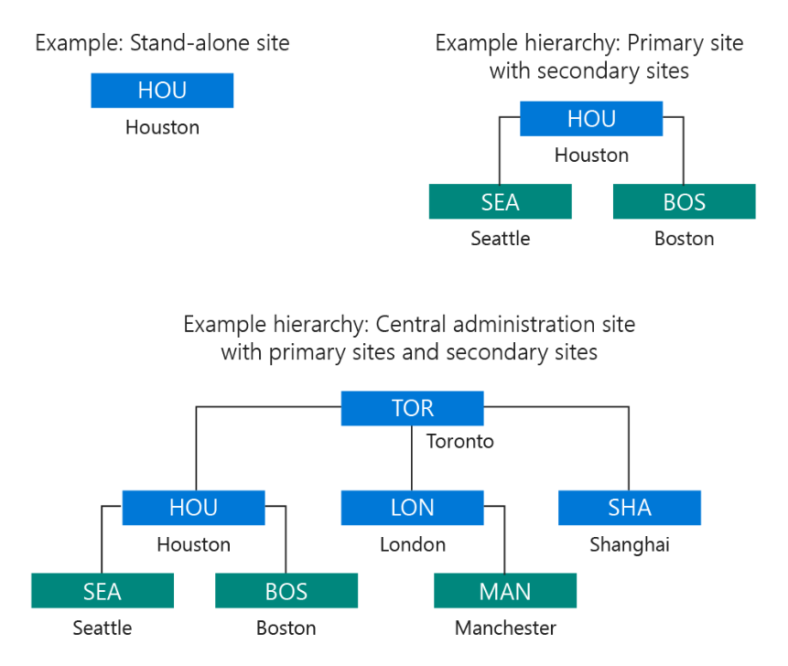

Configuration Manager Site System Roles and Changes
- Explanation: Site system roles are the components that you install on servers to provide specific functionality within a Configuration Manager site. They are the engines that power your management tasks, such as distributing software, providing policies to clients, and collecting inventory data. Different site types (Central Administration, Primary, and Secondary) can host different roles, and some roles can only be installed on specific sites.
- Breakdown: Common Site System Roles
  - Management Point: Provides policy and service location information to clients and receives configuration data from them. Clients communicate directly with a Management Point to get and send information.
  - Distribution Point: Stores content files (applications, software updates, OS images) for clients to download. It's crucial for efficiently distributing content to devices, especially in remote locations.
  - Software Update Point: Integrates with Windows Server Update Services (WSUS) to manage and deploy software updates. It synchronizes update metadata from Microsoft Update and makes it available to clients.
  - Site Database Server: The SQL Server that hosts the site's database. It stores all the information about your Configuration Manager environment.
  - Service Connection Point: Uploads usage data from your site and makes in-console updates for Configuration Manager available. It's required for connecting your Configuration Manager hierarchy to the Microsoft cloud, including services like Intune.
  - SMS Provider: An interface between the Configuration Manager console and the site database. It provides read-and-write access to the database.
- Practical Examples:
  - To deploy a new application to all your desktops, you would use a Distribution Point to store the application content and a Management Point to provide clients with the deployment policy.
  - To get a report on all your managed devices, you would query the Site Database Server.
  - To keep your Configuration Manager up to date, you use the Service Connection Point to download new versions from Microsoft.
- Official Documentation: You can find comprehensive details about site system roles and their functions on the official Microsoft Learn page: Plan for site system servers and site system roles
- Recent Changes and Deprecations: Microsoft is continuously updating Configuration Manager (now part of Microsoft Intune). The product has a semi-annual release cycle, with versions identified by the year and month (e.g., version 2409).
  - SQL Server Changes: As of version 2409, SQL Server 2012 and 2014 are no longer supported.
  - Enhanced Security: There have been enhancements to security, such as support for SQL Extended Protection for Authentication and enhanced security for Cloud Management Gateway (CMG) deployments.
  - Platform Support: Recent versions have added support for newer operating systems like Windows 11 24H2 and Windows Server 2025, and extended features like BitLocker and software metering to ARM64 devices.
  - Deprecations: Microsoft has been deprecating older features to focus on modern management. Some examples include:
    - Sites that use HTTP client communication are deprecated in favor of HTTPS or Enhanced HTTP.
    - The Community Hub service and its integration with Configuration Manager have been removed.
Reference:- What's new in Configuration Manager incremental versions.

How Data Flows and Replicates in a Hierarchy
- Explanation: The data replication process in a Configuration Manager hierarchy is a combination of SQL-based and file-based replication. This dual approach allows for the efficient and reliable transfer of both small, frequently changing administrative data and large, static content files.
- Breakdown:
  - 1. Database Replication (Data Replication Service - DRS)
    - Purpose: This is the primary method for replicating administrative data, such as site settings, collection rules, and other global data, between site databases. It's a "live" replication of the site database itself.
    - Mechanism:
      - SQL Server Service Broker (SSB): Configuration Manager uses its own database replication service (DRS), which is built on top of SQL Server Service Broker (SSB). SSB provides a reliable, asynchronous message queuing service for communication between the SQL Server instances at different sites.
      - Change Tracking: The DRS uses SQL Server's change tracking feature to monitor for changes in the local site database. When a change is detected (e.g., you create a new collection), it's bundled into a message.
      - Replication Groups: Data is organized into "replication groups" with separate, fixed schedules. For example, a change to a security role is in a group that replicates quickly to ensure timely enforcement, while less critical data might have a slower schedule.
      - Flow: The changes are packaged and sent via SSB to the other sites in the hierarchy. Global data is replicated bidirectionally (up and down the hierarchy), while a summary of site-specific data (like inventory) is replicated only from a child primary site up to its parent Central Administration Site (CAS) for centralized reporting.
  - 2. File-based Replication
    - Purpose: This method is used for transferring large content and configuration files that are not stored in the database.
    - Mechanism:
      - Sender: Configuration Manager uses a component called the "Sender" to manage file-based replication between sites.
      - Server Message Block (SMB): The Sender uses the Server Message Block (SMB) protocol to copy files from a source site server to a destination site's SMS_Site share.
      - Content: This includes packages, applications, operating system images, and driver content that you've created for deployment. It also handles initial database snapshots when a new site is installed, which are then loaded into the new site's database using the SQL Server Bulk Copy Program (BCP).
      - Flow: When you distribute an application to a child site, the file-based replication process transfers the content files to that site's distribution points. This process can be configured with schedules and rate limits to control network bandwidth usage.
- How They Work Together: Database replication handles the "what" (the policies and configuration data), while file-based replication handles the "where" (the actual content). The database replication tells a site's clients that a new application is available, and file-based replication ensures the application's source files are available on a local distribution point for those clients to download.
- Official Documentation: You can find more detailed information about these two replication types on the official Microsoft Learn pages:
  - Database replication
  - File-based replication
ConfigMgr SQL Replication Deep Dive

In Configuration Manager, you can monitor the status of sites and components through the Monitoring workspace in the console. This workspace provides several tools to help you understand the health and operational status of your environment.
Here is a breakdown of the key areas for monitoring:
- System Status Node: This is your primary hub for monitoring. Under the Monitoring workspace, navigate to System Status. Here you will find:
  - Site Status: Provides a real-time overview of the health of each site system and its roles. The health status is determined by configurable thresholds for messages and events.
  - Component Status: Shows a rollup of the health for each Configuration Manager component, such as the SMS_SITE_COMPONENT_MANAGER or the SMS_MP_CONTROL_MANAGER.
- Status Messages: Configuration Manager components generate status messages, which are detailed events that provide feedback on site and hierarchy operations. You can access and query these messages to perform in-depth analysis:
  - In the Monitoring workspace, select System Status > Status Message Queries. You can run built-in queries or create custom ones to filter messages for specific components, dates, or severities.
- Configuration Manager Service Manager: For advanced troubleshooting, you can use the Service Manager to directly manage and inspect components.
  - To access it, navigate to the Component Status node, select a component, and on the ribbon, click Start > Configuration Manager Service Manager.
  - From this tool, you can view the status of a component and perform actions like starting, stopping, pausing, or resuming it.
For a deeper dive into how the site server works and how to review its components and log files, you can watch this video: Deep Dive into How the Site Server Works in Configuration Manager (SCCM).
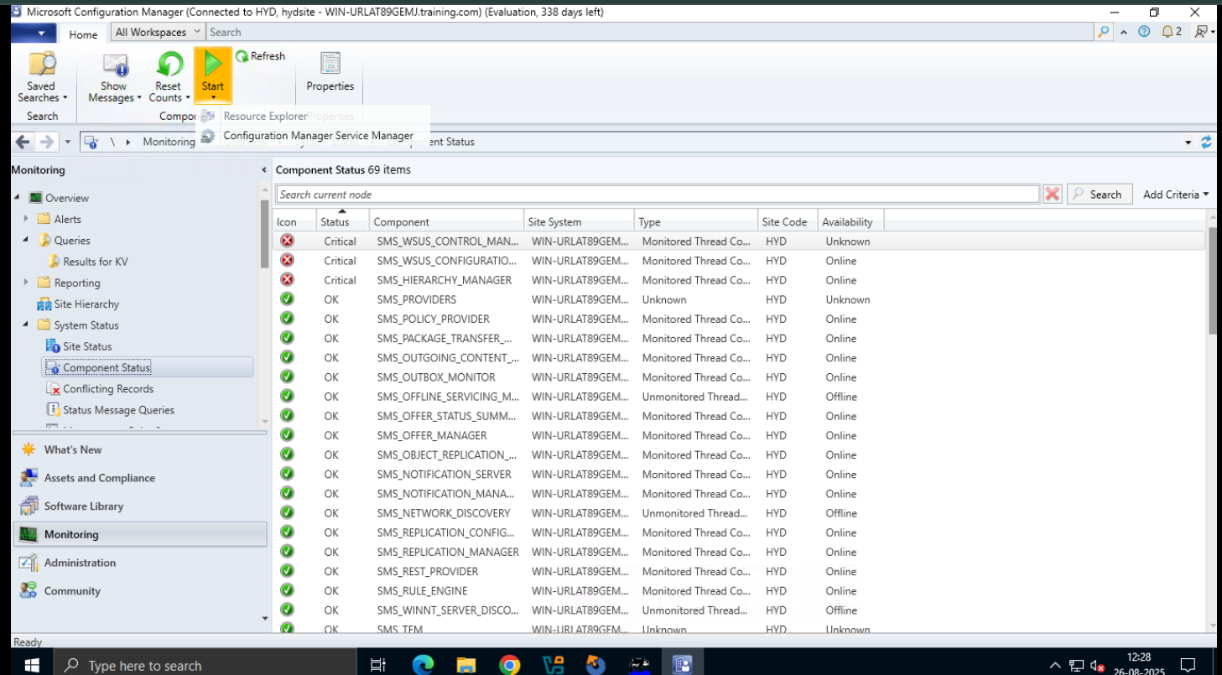

Managing Components by Using Configuration Manager Service Manager
The Configuration Manager Service Manager is a tool for advanced troubleshooting and managing the state of Configuration Manager components. It allows administrators to view and control the services and threads (components) running on a site system.
Here is how you can manage components using the Service Manager:
1. Launching Configuration Manager Service Manager
You can open the Service Manager from within the Configuration Manager console or by running its executable file.
- From the console:
  - Go to the Monitoring workspace.
  - Expand System Status and select the Component Status node.
  - On the ribbon, select Start and then choose Configuration Manager Service Manager.
- From the executable:
  - Navigate to the directory %ProgramFiles%\Microsoft Configuration Manager\AdminConsole\bin\i386.
  - Run the compmgr.exe file.
  - When prompted, enter the name of the site server you want to connect to.
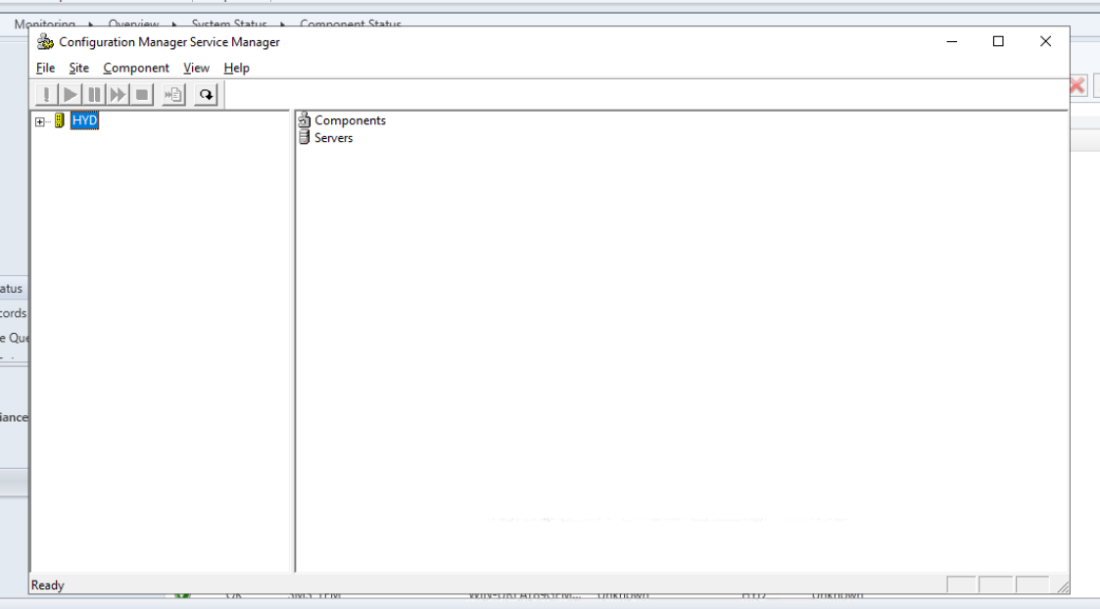
2. Managing Components
Once the Service Manager is open, you can perform various actions on the components.
- In the left pane, expand the site and navigate to either Components or Servers, depending on where the components you want to manage are located.
- In the right pane, select one or more components.
- From the Component menu, you can perform the following actions:
  - Query: This action updates and displays the current status of the selected component (e.g., Running, Stopped, Paused). It is important to query a component to see its most recent status.
  - Start: Runs a component that has been stopped.
  - Stop: Stops a running component.
  - Pause: Temporarily pauses a running component while preserving its runtime environment. This can be useful for troubleshooting.
  - Resume: Resumes a component that has been paused.
By using the Service Manager, you can get a granular view of component health and directly control their operation.
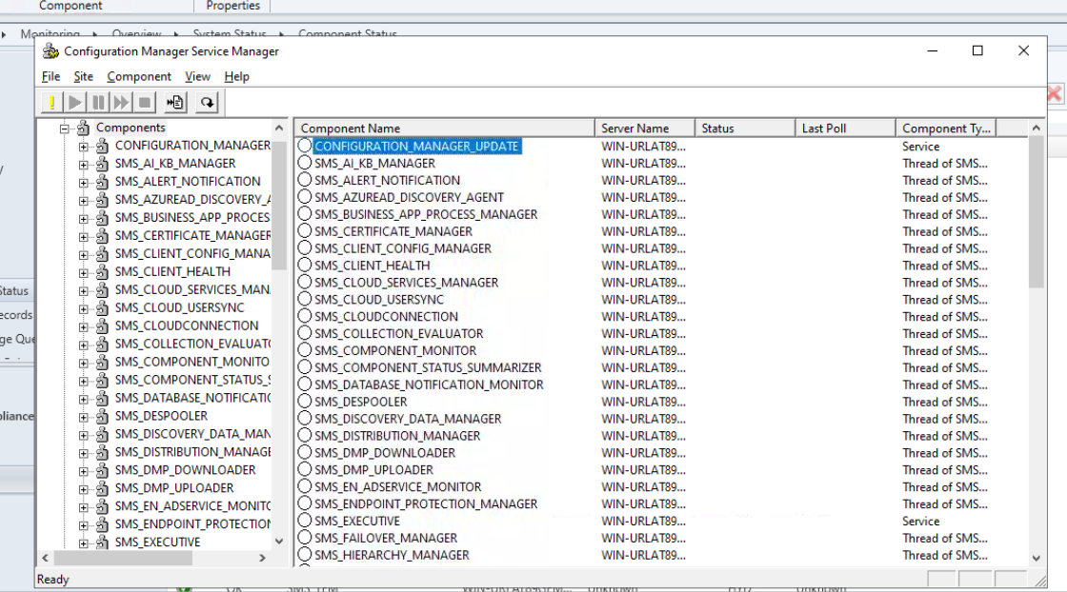
What Are Configuration Manager Log Files?
Configuration Manager log files are essential for troubleshooting and monitoring the activities of your Configuration Manager environment. Client and site server components record information about their processes in individual log files, which are plain text and can be viewed with any text editor, though dedicated tools like CMTrace are recommended for easier reading.
Here's a breakdown of what they are and where to find them:
What They Are
- Purpose: Log files track the processes and events of Configuration Manager components. When a task fails, you can use the logs to identify the source of the problem.
- File Naming: Most log files are identified by a .log or .lo_ extension. When a .log file reaches its size limit, it is renamed with the .lo_ extension and a new .log file is created.
- Viewing Tools: While any text editor can open these files, Microsoft provides a dedicated tool called CMTrace, which is a part of the Configuration Manager installation media and is automatically installed on clients. CMTrace provides features like real-time log monitoring, highlighting of errors, and filtering.
Key Log File Locations
The location of the log files varies depending on the type of computer (client, server, or site role) and the specific process.
- Client Logs: Found on client computers, typically in %WinDir%\CCM\Logs.
- Server Logs: Found on the site server in the Configuration Manager installation directory, typically C:\Program Files\Microsoft Configuration Manager\Logs.
- Management Point Logs: Located at C:\SMS_CCM\Logs.
- Configuration Manager Console Logs: Located at C:\Program Files (x86)\Microsoft Endpoint Manager\AdminConsole\AdminUILog.
- Operating System Deployment (OSD) Logs: The location of the smsts.log file changes depending on the phase of the task sequence, but it is a crucial log for OSD troubleshooting.
For a comprehensive list of all log files, you can refer to the official Microsoft documentation or various online guides.
You can learn more about SCCM client-side logs by watching a video on the topic. System Center Configuration Manager - Client Side Logs explanation in-depth

